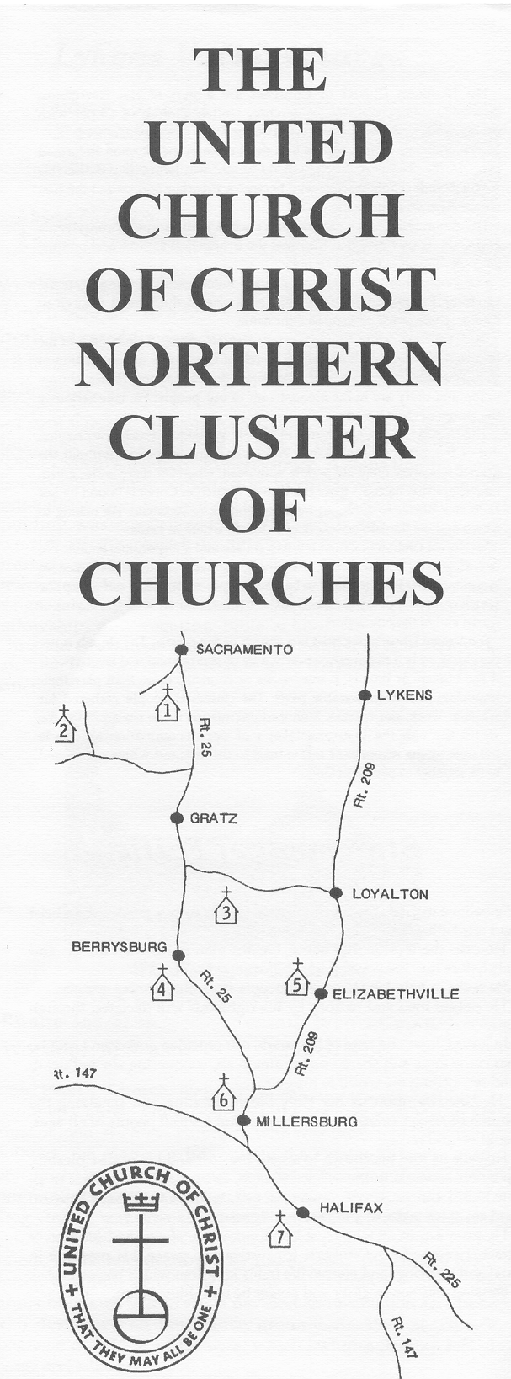
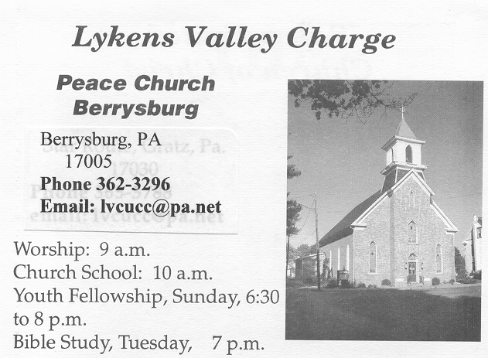
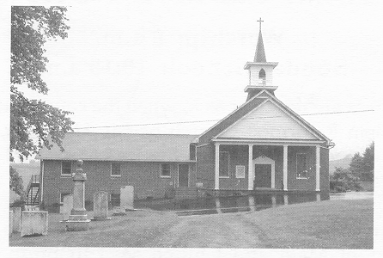
Lykens Valley Charge
150 North Chestnut Street, Box 268
Berrysburg, PA 17005
717-362-3296
lvcucc@frontier.com
1289 South Crossroads
Lykens, PA 17048
717-362-3296
lvcucc@frontier.com
Peace UCC

St. Peter’s UCC

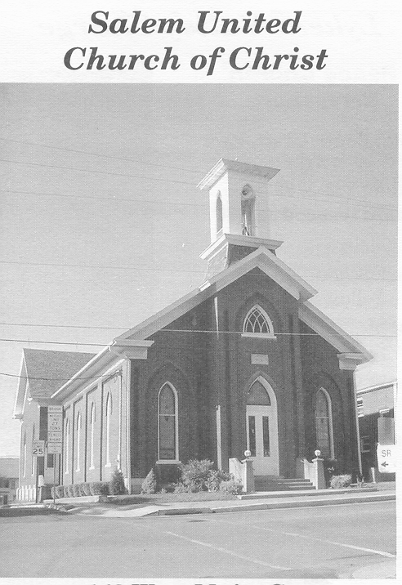
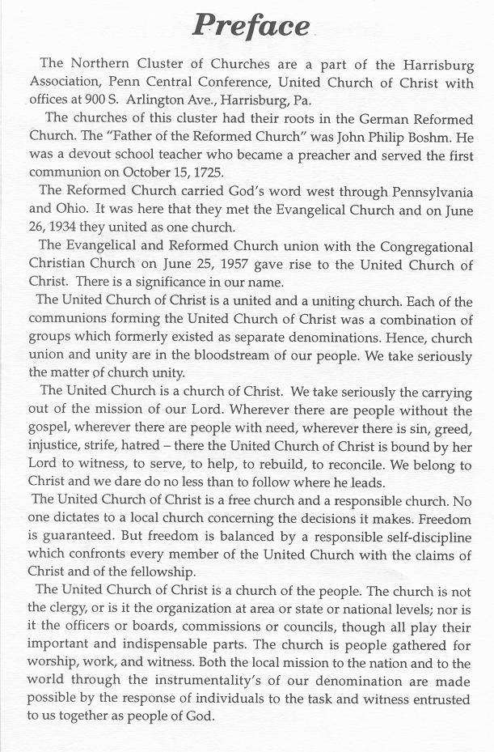
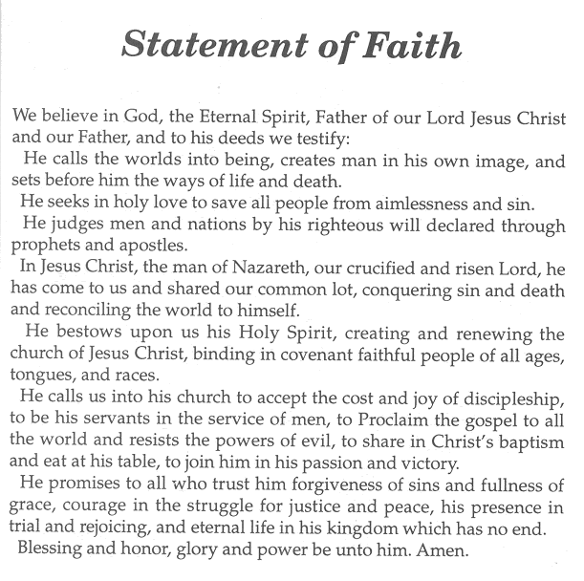
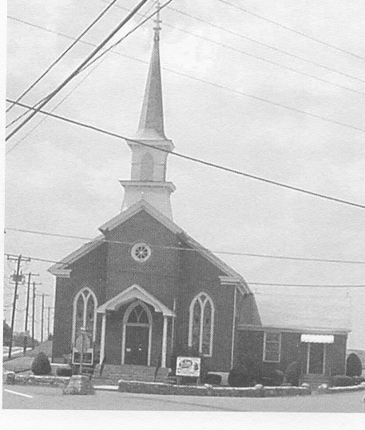
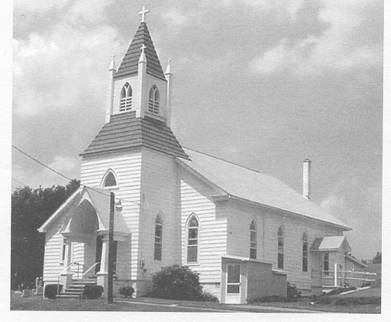
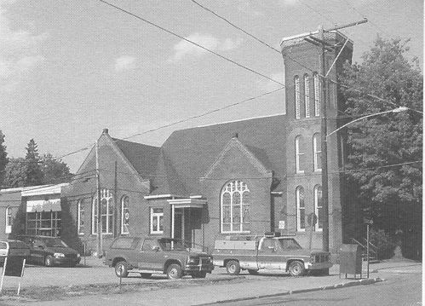
141 West Main Street, P.O. Box 307
Elizabehtville, PA 17023
717-362-8221
salemuccchurch@comcast.net
2338 East Main Street
Sacramento, PA 17968
570-682-9828
stpaulsucc.sacramento@gmail.com
Coleman Church Road, P.O. Box 71
Spring Glen,, PA 17978
717-365-9974
stmattsucc@pa.net
St. Paul’s UCC
St. Matthew’s UCC
Salem UCC
Trinity UCC
235 Center Street
Millersburg, PA 17061
717-692-2921
trinityuc@frontier.com

